

CSE302 (Section 1)
[Summer 2022]

Lab Assignment Submission Report

Assignment Title: Lab tasks of LAB05

Submitted by:
Aisha Siddika Mim
2020-1-60-040

1. Screenshots

LAB TASK 01 (WITHOUT SUBQUERIES):

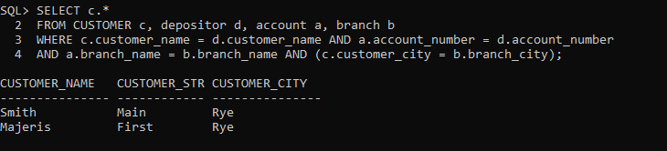

LAB TASK 01 (WITH SUBQUERY):

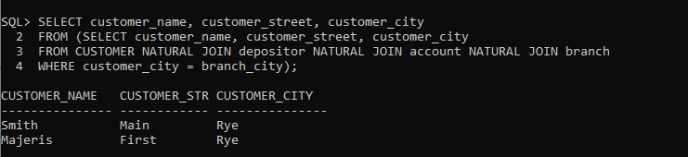

LAB TASK 02 (WITHOUT SUBQUERIES):

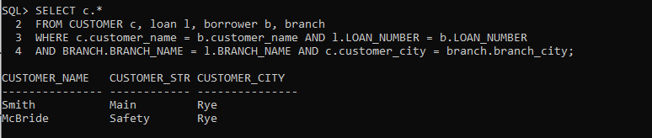

LAB TASK 02 (WITH SUBQUERY):

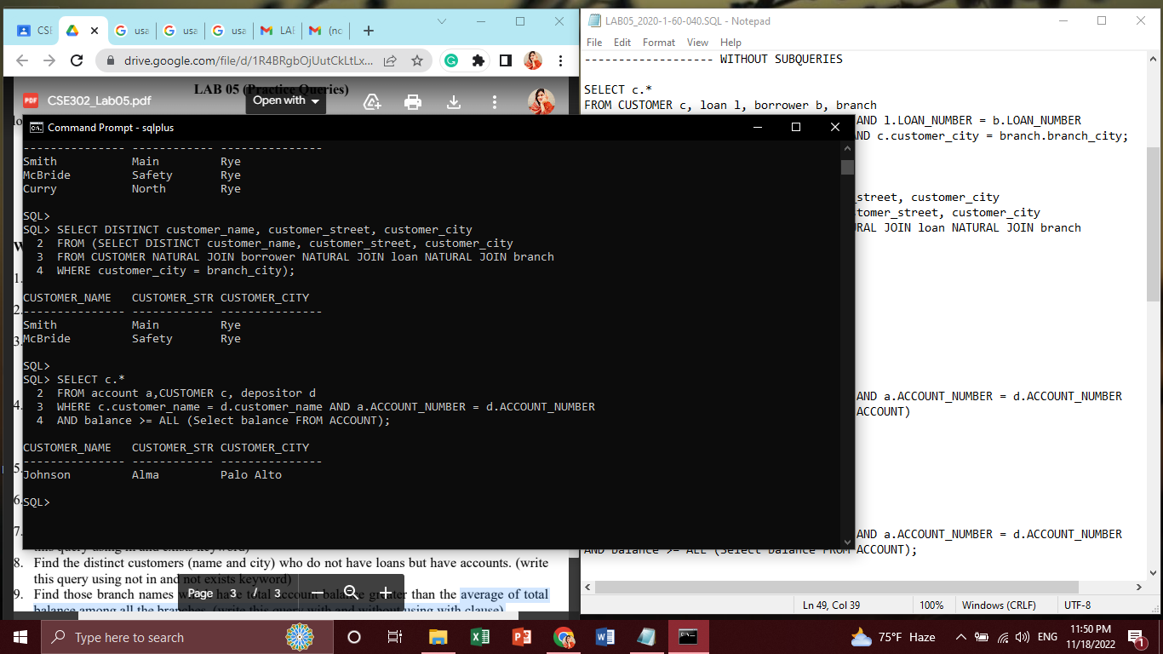
LAB TASK 03 (USING HAVING):

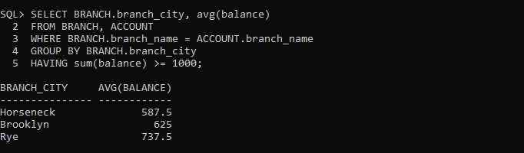

LAB TASK 03 (WITHOUT USING HAVING):

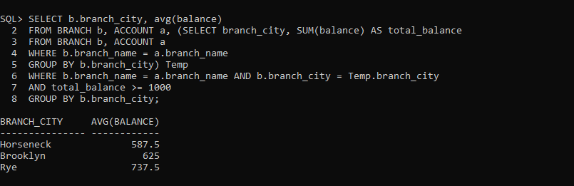

LAB TASK 04 (USING HAVING):

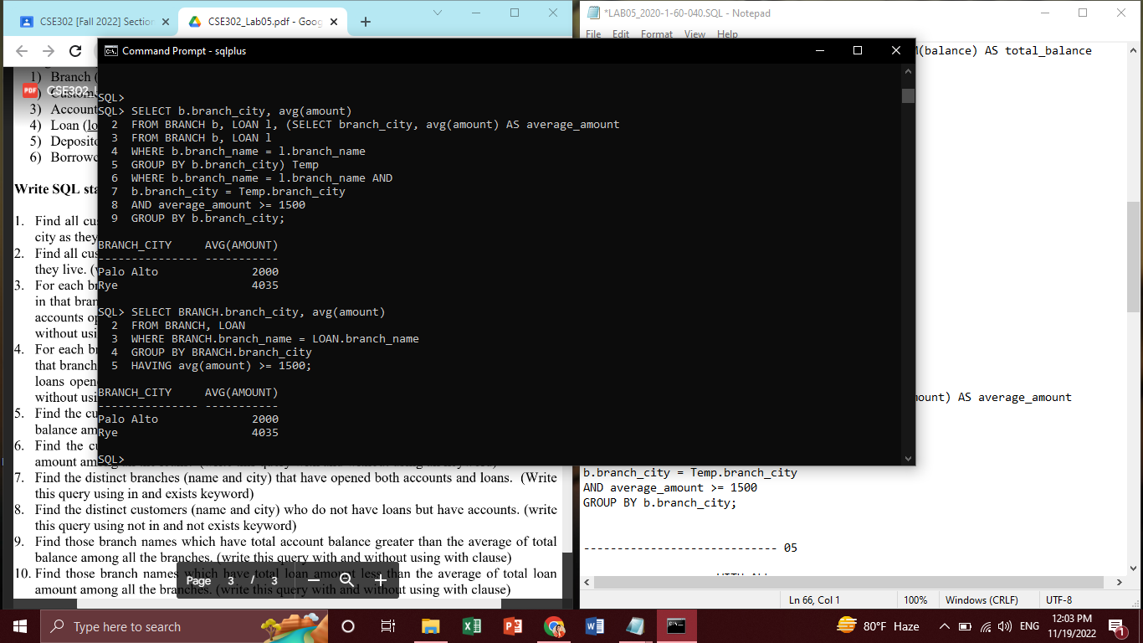

LAB TASK 04 (WITHOUT USING HAVING):

LAB TASK 05 (USING ALL):

LAB TASK 05 (WITHOUT USING ALL):

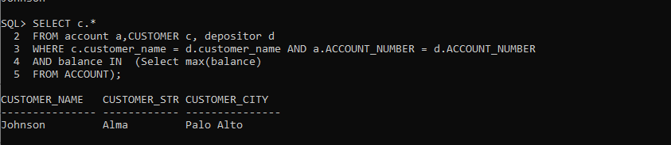

LAB TASK 06 (USING ALL):

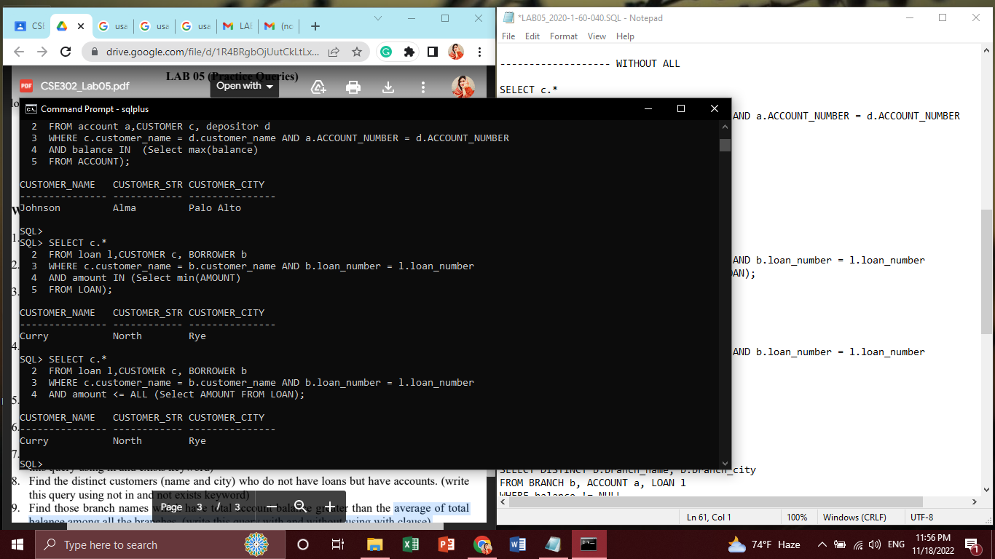

LAB TASK 06 (WITHOUT USING ALL):

LAB TASK 07 (USING IN):

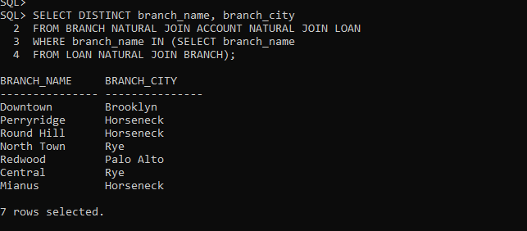

LAB TASK 07 (USING EXISTS):

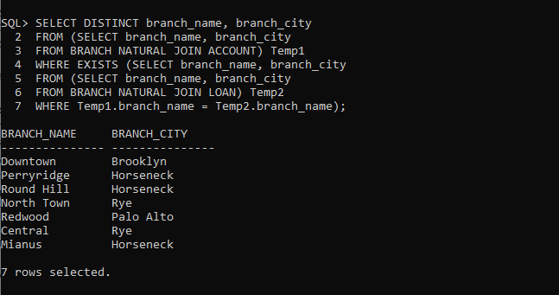

LAB TASK 08 (USING NOT IN):

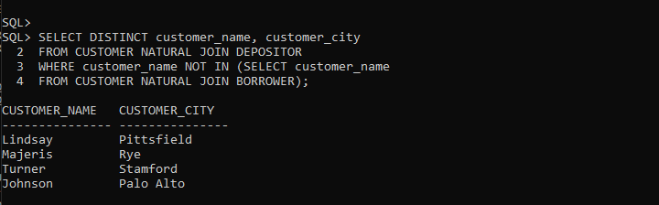

LAB TASK 08 (USING NOT EXISTS):

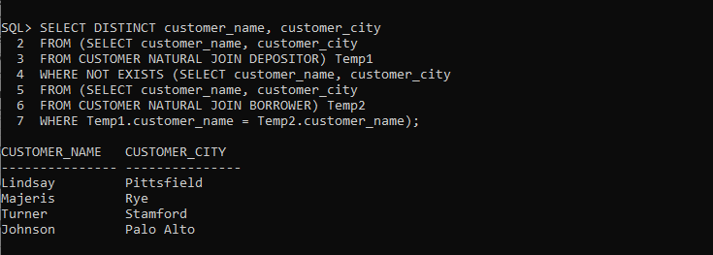

2. Learning Outcomes

From this lab, I learned how to write queries with and without using subquery, In, Exists, Not In, Not Exists, Having, All keywords and clauses.

